# Chapter 1 (textbook questions)

## Adriana Coert 20240201

# Questions

1. Which of these refers to the connectivity between different external networks?

(A) VPN  
(B) Intranet  
(C) Internet  
(D) DMZ

2. Which of these does not allow us to identify a device on the network?

(A) Virtual port number  
(B) IP address  
(C) MAC address  
(D) Hostname

3. Replace the underlined word in the following statement with the correct word(s). If you believe the statement is already correct, then select *No change is required*:  
A DMZ allows or denies network traffic based on a set of rules.

(A) VPN  
(B) Internet  
(C) Firewall  
(D) No change is required

4. Which of these technologies allows you to securely connect to a private network over an insecure network?

(A) Extranet  
(B) DMZ  
(C) Firewall  
(D) VPN

5. Which of the following devices would you most likely position within a DMZ?

(A) Domain controller  
(B) DHCP server  
(C) Print server  
(D) Web server

6. What is the default security level for Restricted sites?

(A) Low  
(B) Medium-Low  
(C) Medium-High  
(D) High

7. What network protocol is used by the ping utility?

(A) DHCP  
(B) ICMP  
(C) ARP  
(D) PPTP

8. When would you use a VPN concentrator at both ends of the VPN tunnel?

(A) When home-based users are connecting to the head office  
(B) When field-based engineers are connecting to the head office  
(C) When a branch office is connecting to the head office  
(D) None of the above

9. Which of the following would you implement to allow trusted third parties to gain limited access to your internal network?

(A) Extranet  
(B) DMZ  
(C) Firewall  
(D) Internet

1. What protocol is used to map an IP address to a MAC address?

(A) DHCP  
(B) ICMP  
(C)HTTP  
(D) ARP

2. Which of the following is a valid MAC address format?

(A) AA:AA:12:34::AA:AA  
(B) AB:F1:1B:FE:12:D1:65:91  
(C) AB:12:12:CA:1F  
(D) AG:CA:1F:AA:11:DA

3. What type of data transmission allows traffic to flow in both directions at the same time?

(A) Unidirectional  
(B) Simplex  
(C) Half-duplex  
(D) Full-duplex

4. Which of the following describes a network that spans a city?

(A) CAN  
(B) LAN  
(C) MAN  
(D) WAN

5. An IP address that can be used locally within your network and is not routable across the internet is known as what?

(A) An alternate private IP address  
(B) Private IP address  
(C) Public IP address  
(D) ARP

6. Which of these commands will display the MAC addresses of your interfaces?

(A) ipconfig /all  
(B) show mac  
(C) display mac  
(D) ifconfig /all

7. What identifier does a switch use when making a forwarding decision?

(A) Destination IP address  
(B) Source IP address  
(C) Destination MAC address  
(D) Source MAC address

8. A network that covers a small geographical area is known as a _______. Fill in the blank:

(A) CAN  
(B) LAN  
(C) MAN  
(D) WAN

9. Which of the following is the broadcast MAC address?

(A) aa:aa:aa:aa:aa:aa  
(B) ff:ff:ff:ff:ff:ff  
(C) 11:11:11:11:11:11  
(D) 99:99:99:99:99:99

10. Looking at the following diagram, if **Computer A** sent a broadcast transmission, which devices would receive the data? Do not include **Computer A** in the count.

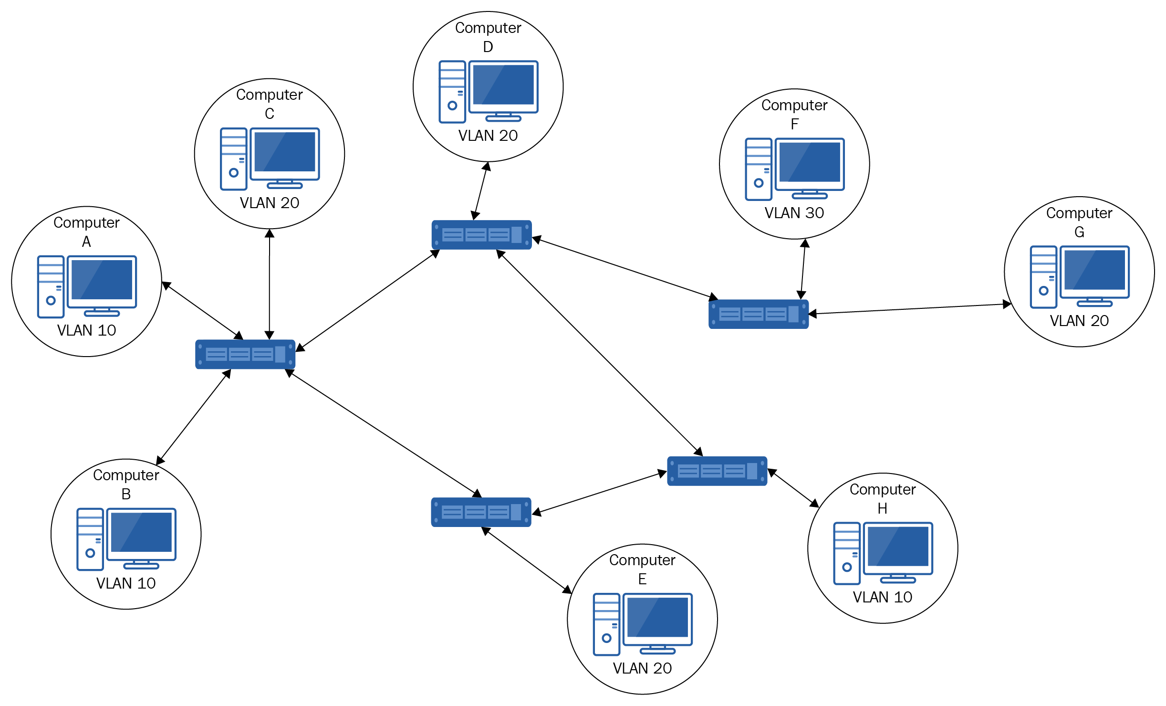

(A) 2  
(B) 3  
(C) 7  
(D) 8

1. What type of network medium is used by SONET?

(A) UTP  
(B) Coaxial  
(C) Wireless  
(D) Optical

2. What is the speed of an E3 connection?

(A) 1.544 Mb/s  
(B) 2.048 Mb/s  
(C) 34.368 Mb/s  
(D) 44.736 Mb/s

3. Which devices convert digital signals to analog signals for transmission over the telephone network?

(A) Modem  
(B) Switch  
(C) Router  
(D) Telnet

4. Which device in a packet-switching network is most likely to function as a PAD?

(A) Modem  
(B) Switch  
(C) Router  
(D) Telnet

5. How many B channels does an ISDN Basic Rate Interface have?

(A) 1  
(B) 2  
(C) 3  
(D) 4

6. Which WAN technology used fixed-size cells to transfer data?

(A) Frame relay  
(B) Packet switching  
(C) ATM  
(D) 3G

7. Which of the following is used for error checking in X.25 networks?

(A) CRC  
(B) ATM  
(C) ECC  
(D) PSE

8. If you had a committed information rate (CIR) of 128 Kb/s, what would the burst excess be?

(A) 128 Kb/s  
(B) 192 Kb/s  
(C) 224 Kb/s  
(D) 320 Kb/s

9. What device routes traffic around a packet-switched network?

(A) PSE  
(B) PAD  
(C) CSU/DSU  
(D) DTE

1. Wi-Fi networks use which access method?

(A) Token ring  
(B) CSMA/CD  
(C) CSMA/CW  
(D) CSMA/CA

2. A junior network technician needs to set up an access point using 802.11g. What frequency will it use?

(A) 2.4 Hz  
(B) 2.4 KHz  
(C) 2.4 GHz  
(D) 2.5 THz

3. Which 802.11 standard has the furthest indoor range?

(A) 802.11g  
(B) 802.11a  
(C) 802.11n  
(D) 802.11ac

4. What type of wireless topology would be used when you want to connect two devices directly together in a peer-to-peer relationship?

(A) WDS  
(B) Ad-hoc mode  
(C) Infrastructure mode  
(D) Wireless bridge

5. Which of these Wi-Fi security standards takes advantage of EAP?

(A) WEP-PSK  
(B) WEP-Enterprise  
(C) WPA-PSK  
(D) WPA2-Enterprise

6. Which of these Wi-Fi standards does not use a 5 GHz frequency?

(A) 802.11b  
(B) 802.11a  
(C) 802.11n  
(D) 802.11ac

7. You have a wireless network that supports 802.11g, but you have noticed that the network seems to be running at 11 Mbps. What is the most likely cause of this?

(A) EMI  
(B) Incorrect encryption standard selected  
(C) Interference from Bluetooth devices  
(D) You have an 802.11b device on the network

8. The EAP falls under which standard?

(A) 802.1a  
(B) 802.1x  
(C) 802.11b  
(D) 802.11x

1. In a token ring network, what is the central device known as?

(A) MAU  
(B) Switch  
(C) Router  
(D) Server

2. Which access method is used on a bus topology?

(A) Token  
(B) CSMA/CA  
(C) Ticket  
(D) CSMA/CD

3. All devices in a star topology are unable to communicate with each other. What is most likely at fault?

(A) Operating system  
(B) Network card  
(C) Switch  
(D) Cable

4. FDDI utilizes which form of topology?

(A) Bus  
(B) Ring  
(C) Star  
(D) Mesh

5. In a full mesh network consisting of five devices, how many interfaces are required in total?

(A) 4  
(B) 5  
(C) 10  
(D) 20

6. Which topology offers the best fault tolerance?

(A) Full mesh  
(B) Star  
(C) Partial mesh  
(D) Bus

7. Which IEEE standard covers token ring?

(A) 802.1  
(B) 802.3  
(C) 802.5  
(D) 802.15

8. Which type of topology is shown in the following diagram?

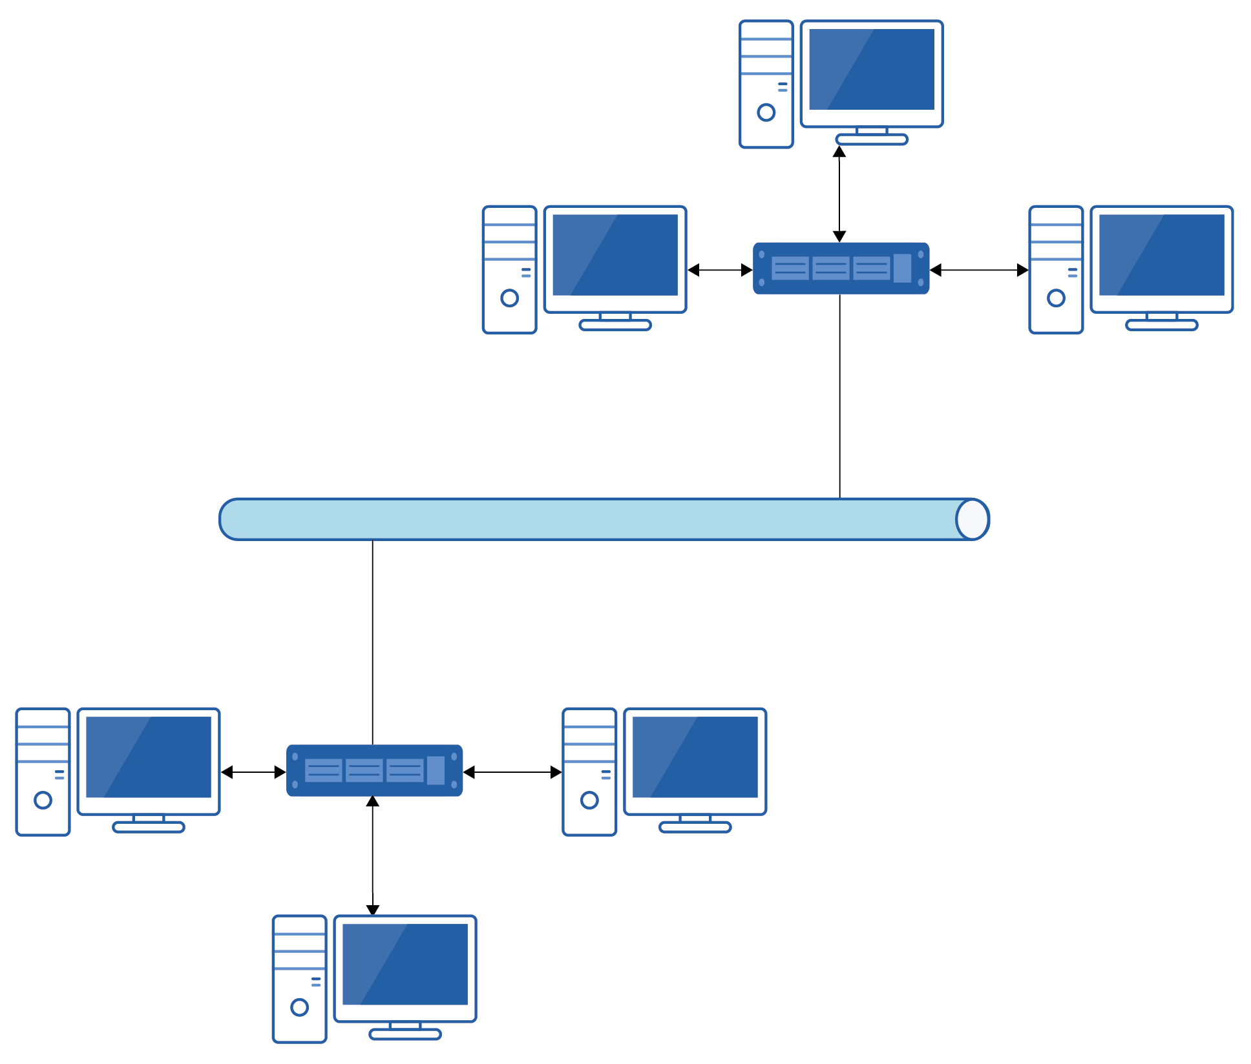

(A) Bus  
(B) Partial mesh  
(C) Star  
(D) Hybrid